Multiple Choice

1. What is the molecular formula of limonene, the major volatile compound in orange peel oil?
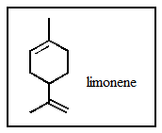
 | a. | C₁₀H₁₈
 | b. | C₁₀H₂₀
 | c. | C₁₀H₁₆
 | d. | C₁₁H₁₄
 | e. | C₁₁H₁₈

ANSWER: | c

2. Of those indicated, which would be the shortest carbon-carbon bond in -selinene?
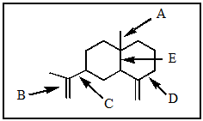
 | a. | A
 | b. | B
 | c. | C
 | d. | D
 | e. | E

ANSWER: | b

3. What would be the ideal value for the indicated bond angle?
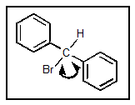
 | a. | 120°
 | b. | 90°
 | c. | 104°
 | d. | 180°
 | e. | 109°

ANSWER: | e

4. Which structure matches the following condensed structure?
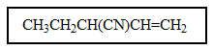
 | a. | 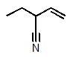
 | b. | 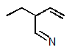
 | c. | 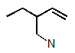
 | d. | 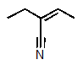
 | e. | 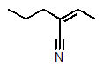

ANSWER: | a

5. Which one of the following structures must be incorrect?
 | a. | 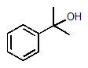
 | b. | 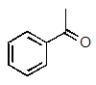
 | c. | 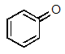
 | d. | 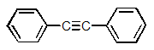
 | e. | 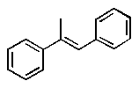

ANSWER: | c

6. Which of the following is not a resonance structure of the others?
 | a. | 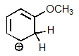
 | b. | 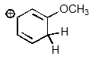
 | c. | 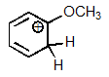
 | d. | 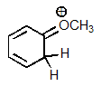
 | e. | 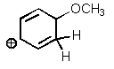

ANSWER: | e

7. Which one of the resonance structures below would be the most important (i.e., most stable)?
 | a.
 | b. | 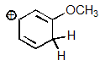
 | c. | 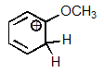
 | d. | 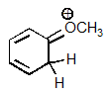
 | e. | 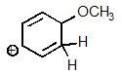

ANSWER: | d

8. How many atoms in ethene are required by sp² bonding to lie in the same plane?
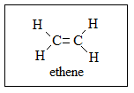
 | a. | 2
 | b. | 3
 | c. | 4
 | d. | 5
 | e. | 6

ANSWER: | e

9. Which one of the following structures is not chemically identical to the others?
 | a. | 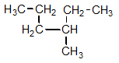
 | b. | 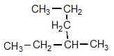
 | c. | 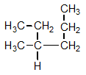
 | d. | 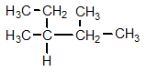
 | e. | 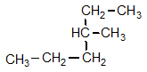

ANSWER: | d

10. Which of the following pairs are not resonance structures of each other?
 | a. | 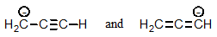
 | b. | 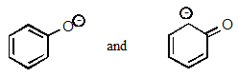
 | c. | 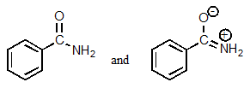
 | d. | 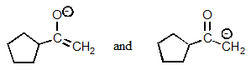
 | e. | All are pairs of resonance structures.

ANSWER: | e

11. How many hydrogen atoms are part of the following steroid?
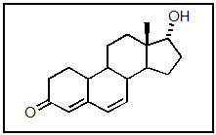
 | a. | 18
 | b. | 20
 | c. | 21
 | d. | 22
 | e. | 24

ANSWER: | e

12. In the following molecule, how many carbon atoms are in the sp³ hybridization state?
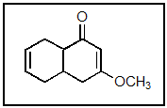
 | a. | 2
 | b. | 4
 | c. | 5
 | d. | 6
 | e. | 11

ANSWER: | d

13. In the following molecule, how many carbon atoms are in the sp² hybridization state?
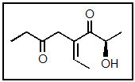
 | a. | 0
 | b. | 1
 | c. | 2
 | d. | 4
 | e. | 6

ANSWER: | d

14. In the following molecule, how many carbon atoms are in the sp hybridization state?
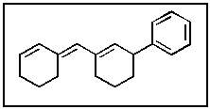
 | a. | 2
 | b. | 4
 | c. | 6
 | d. | 12
 | e. | None of the above.

ANSWER: | e

15. The lone-pair of electrons on nitrogen in the following molecule reside in what type of orbital?
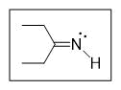
 | a. | sp³  ​
 | b. | sp²  ​
 | c. | sp
 | d. | 2p
 | e. | 2s

ANSWER: | b

16. In the following molecule, how many carbon atoms are in the sp² hybridization state?
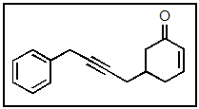
 | a. | 1
 | b. | 3
 | c. | 7
 | d. | 8
 | e. | 9

ANSWER: | e

17. The boxed item most likely represents what?
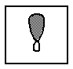
 | a. | s orbital
 | b. | sp³ orbital
 | c. | p orbital
 | d. | could be any of A–C
 | e. | None of the above.

ANSWER: | b

18. The following molecule contains how many carbon atoms in the sp hybridization state?
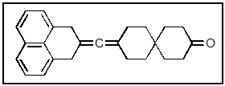
 | a. | 1
 | b. | 3
 | c. | 8
 | d. | 13
 | e. | 16

ANSWER: | a

19. The nitrogen of trimethylamine [(CH₃)₃N] contains how many lone pairs of electrons?
 | a. | none
 | b. | one
 | c. | two
 | d. | three
 | e. | there is no nitrogen in this molecule

ANSWER: | b

20. A positive charge on oxygen generally occurs when:
 | a. | oxygen has too many electrons.
 | b. | oxygen has too few electrons.
 | c. | oxygen is sharing one of its non-bonding electron pairs.
 | d. | oxygen has too many non-bonding electron pairs.
 | e. | oxygen is borrowing electrons from another atom.

ANSWER: | c

21. The carbon atom in CH₂Cl₂ has what hybridization?
 | a. | sp
 | b. | sp²
 | c. | sp³
 | d. | sp⁴
 | e. | they are not hybridized

ANSWER: | c

22. The molecular formula for piperitone is
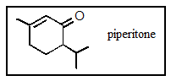
 | a. | C₉H₁₆O
 | b. | C₁₀H₁₈O
 | c. | C₉H₁₈O
 | d. | C₁₀H₁₄O
 | e. | C₁₀H₁₆O

ANSWER: | e

23. Which structure is different from the others?
 | a. | 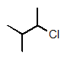
 | b. | CH₃CHClCH(CH₃)₂  ​
 | c. | 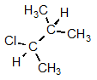
 | d. | 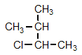
 | e. | All are identical.

ANSWER: | e

24. A fairly common algal metabolite is the compound (-)-geosmin, which imparts a musty odor to water even at concentrations in the ppb range. What is the molecular formula of geosmin?
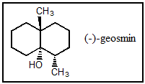
 | a. | C₁₁H₂₀O
 | b. | C₁₂H₂₂O
 | c. | C₁₁H₂₁O
 | d. | C₁₂H₂₀O
 | e. | C₁₂H₂₁O

ANSWER: | b

25. Which of the carbon-carbon bonds indicated would you expect to be the longest in stilbene?
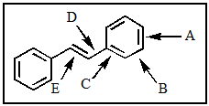
 | a. | A
 | b. | B
 | c. | C
 | d. | D
 | e. | E

ANSWER: | d

26. Which of the following pairs are not resonance structures of each other?
 | a. | 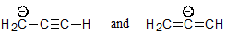
 | b. | 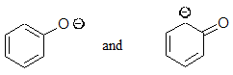
 | c. | 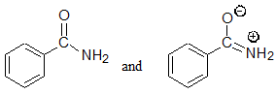
 | d. | 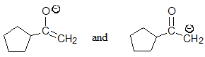
 | e. | All are pairs of resonance structures.

ANSWER: | a

27. The following molecule has what molecular formula?
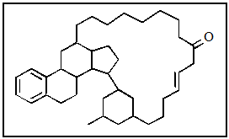
 | a. | C₃₉H₅₈O
 | b. | C₄₀H₅₈O
 | c. | C₃₉H₆₀O
 | d. | C₄₄H₄₄O
 | e. | None of the above.

ANSWER: | a

28. What is the molecular formula of carvone, the major volatile compound in caraway oil?
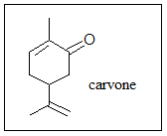
 | a. | C₁₀H₁₈O
 | b. | C₁₀H₁₇O
 | c. | C₁₀H₁₆O
 | d. | C₁₀H₁₄O
 | e. | C₁₀H₁₅O

ANSWER: | d

29. Of those indicated, which would be the shortest carbon-carbon bond in -cadinene?
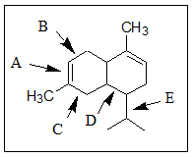
 | a. | A
 | b. | B
 | c. | C
 | d. | D
 | e. | E

ANSWER: | a

30. What would be the ideal value for the indicated bond angle?
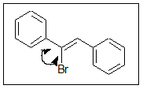
 | a. | 120°
 | b. | 90°
 | c. | 104°
 | d. | 180°
 | e. | 109°

ANSWER: | a

31. Which structure matches the following condensed structure?
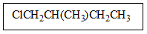
 | a. | 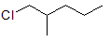
 | b. | 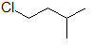
 | c. | 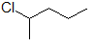
 | d. | 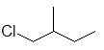
 | e. | 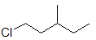

ANSWER: | d

32. Which one of the following structures must be incorrect?
 | a. | 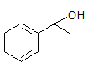
 | b. | 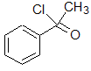
 | c. | 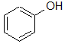
 | d. | 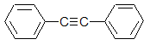
 | e. | 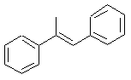

ANSWER: | b

33. How many sp² hybridized carbon atoms are in the potent anticancer compound hydroxymethylacylfulvene?
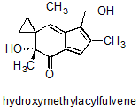
 | a. | 2
 | b. | 4
 | c. | 6
 | d. | 8
 | e. | None of the above.

ANSWER: | e

34. In the following molecule, how many carbon atoms are in the sp³ hybridization state?
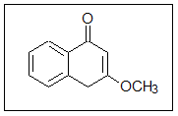
 | a. | 2
 | b. | 4
 | c. | 5
 | d. | 6
 | e. | 9

ANSWER: | a

35. Which of the following statements are true of sp orbitals?
 | a. | Orbitals of the sp type are 50% s and 50% p character.
 | b. | They are hybrid orbitals.
 | c. | They are linear.
 | d. | They result when one s orbital and one p orbital are mixed.
 | e. | All are correct.

ANSWER: | e

36. Which of the following molecules are most likely to be held together by a purely covalent bond?
 | a. | NaCl
 | b. | H₂
 | c. | HF
 | d. | BH₃
 | e. | KI

ANSWER: | b

37. What is the molecular formula of camphor?
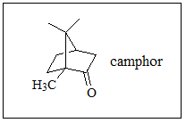
 | a. | C₁₀H₁₅O
 | b. | C₁₀H₁₆O
 | c. | C₁₀H₁₇O
 | d. | C₁₁H₁₈O
 | e. | C₁₁H₁₆O

ANSWER: | b

38. Camptothecin is an important anticancer compound; how many carbons are in the sp hybridization state?
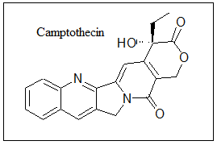
 | a. | 0
 | b. | 1
 | c. | 2
 | d. | 3
 | e. | 4

ANSWER: | a

39. How many sp³ carbons are in the following molecule?
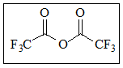
 | a. | 0
 | b. | 1
 | c. | 2
 | d. | 3
 | e. | 4

ANSWER: | c

40. The process of adding electrons one by one to atomic orbitals beginning with the lowest energy is described by:
 | a. | the Aufbau Principle.
 | b. | Hund's Rule.
 | c. | the de Broglie Relation.
 | d. | the Pauli Exclusion Principle.
 | e. | Coulomb's Law.

ANSWER: | a

41. Which of the following cannot be a correct Lewis structure?
 | a. | 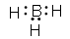
 | b. | 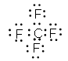
 | c. | 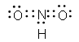
 | d. | 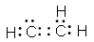
 | e. | All are correct.

ANSWER: | c

42. How many different resonance structures can be drawn for the benzyl cation (shown below) which place the plus charge on a carbon atom in the ring?
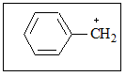
 | a. | 1
 | b. | 2
 | c. | 3
 | d. | 5
 | e. | 6

ANSWER: | c

43. Which of the following represent resonance contributing Lewis structures for CH₂N₂?
 | a. | 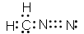
 | b. | 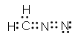
 | c. | 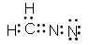
 | d. | 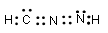
 | e. | both A and B are correct

ANSWER: | e

44. The following molecule belongs to a class of compounds known as allenes. Based on your knowledge of bonding, predict the hybridization of the carbon atom indicated by the arrow.
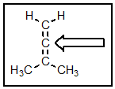
 | a. | sp
 | b. | sp²
 | c. | sp³
 | d. | p-p pi
 | e. | a hypervalent carbon

ANSWER: | a

45. How many isomers of C₄H₉Br are possible?
 | a. | two
 | b. | three
 | c. | four
 | d. | five
 | e. | six

ANSWER: | c

46. How many isomers of C₅H₁₂ are possible?
 | a. | two
 | b. | three
 | c. | four
 | d. | five
 | e. | six

ANSWER: | b

47. Which of the following most correctly defines "structural isomers"?
 | a. | molecules with different molecular formulas but the same connectivity
 | b. | compounds that are not constitutional isomers
 | c. | molecules with the same molecular formula but different connectivity
 | d. | Anti and gauche conformers
 | e. | both B and C

ANSWER: | c

48. How many structural isomers exist for the formula C₆H₁₄?
 | a. | 3
 | b. | 4
 | c. | 5
 | d. | 6
 | e. | 7

ANSWER: | c

49. A hydrocarbon with a double bond and a ring will have the general formula?
 | a. | C_{n}H_{2n+2}
 | b. | C_{n}H_{2n}
 | c. | C_{n}H_{2n-2}
 | d. | C_{n}H_{2n-4}
 | e. | C_{2n}H_{2n}

ANSWER: | c

50. What is the hybridization of the each of the labeled atoms for the potent neurotoxin (-)-gephyrotoxin?
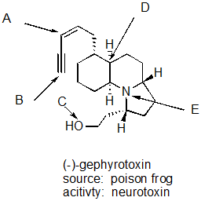
 | a. | A = sp², B = sp, C = sp², D = sp³, E = sp³
 | b. | A = sp², B = sp, C = sp³, D = sp³, E = sp²
 | c. | A = sp², B = sp, C = sp², D = sp³, E = sp²
 | d. | A = sp², B = sp, C = sp³, D = sp³, E = sp³
 | e. | A = sp, B = sp, C = sp³, D = sp³, E = sp³

ANSWER: | d

